SMD TASK March 4, 2025

Name: Muhammad Abu Huraira

Roll: 22F-3853

Section: BCS-6B

Get app inspection by

View >tool window >app inspection

Write operation

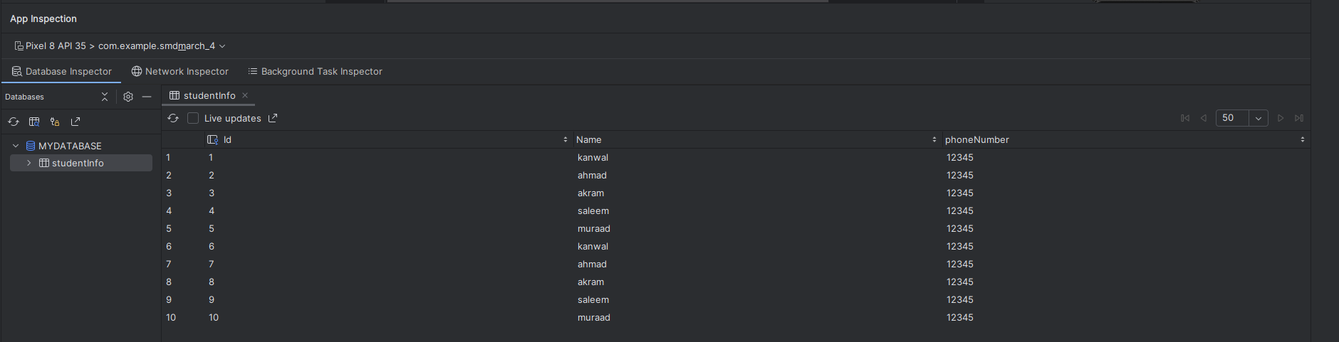

READ operation

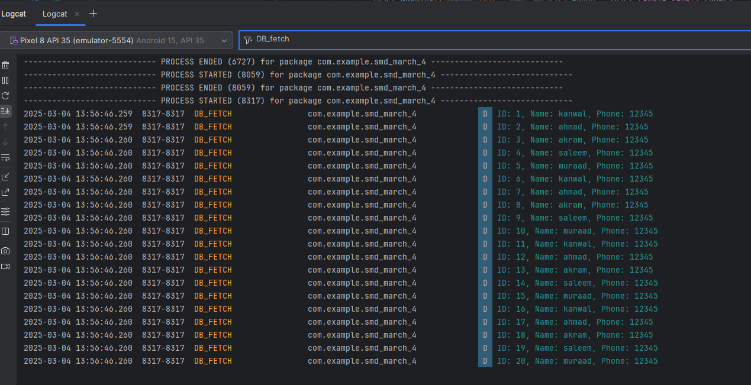

UPDATE



Delete



Home task output:

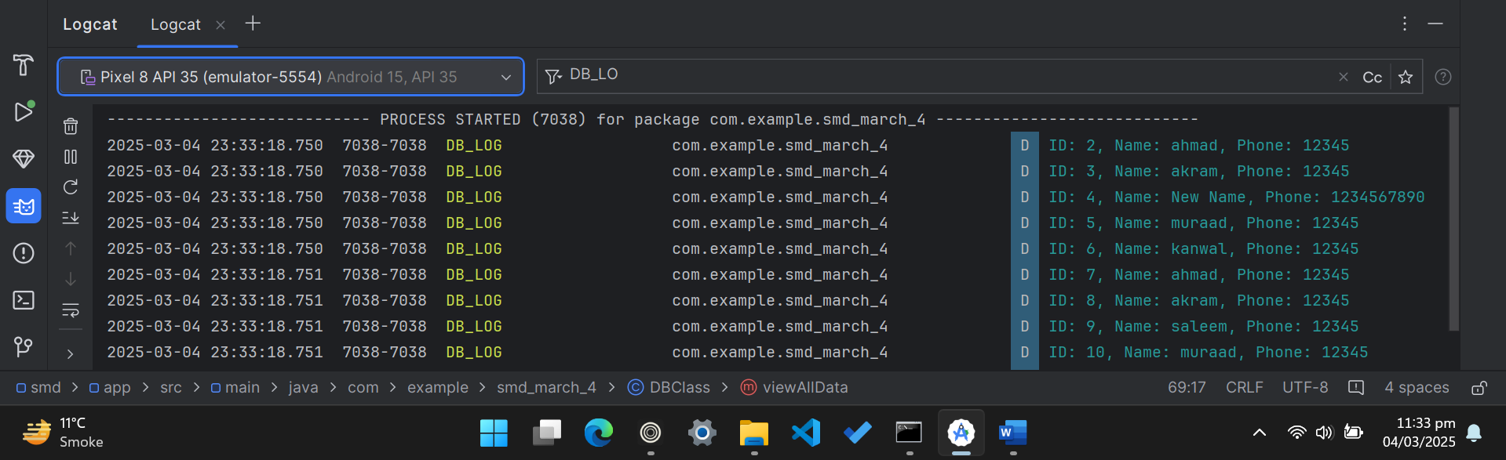

After deleting all the data entries



Code file

DBclass java file

package com.example.smd_march_4;  
  
import android.content.ContentValues;  
import android.content.Context;  
import android.database.Cursor;  
import android.database.sqlite.SQLiteDatabase;  
import android.database.sqlite.SQLiteOpenHelper;  
import android.util.Log;  
  
import androidx.annotation.Nullable;  
  
public class DBClass extends SQLiteOpenHelper {  
 private static final String *NAME*="MYDATABASE";  
 private static final int *VERSION*=1;  
 private static final String *TABLE_NAME*="studentInfo";  
  
 private static final String *KEY_ID*="Id";  
 private static final String *KEY_NAME*="Name";  
 private static final String *KEY_PHONE_NUMBER*="phoneNumber";  
  
 public DBClass(@Nullable Context context) {  
 super(context, *NAME*, null, *VERSION*);  
 }  
  
 @Override  
 public void onUpgrade(SQLiteDatabase db, int oldVersion, int newVersion) {  
 db.execSQL("DROP TABLE IF EXISTS " + *TABLE_NAME*);  
 onCreate(db);  
 }  
  
 @Override  
 public void onCreate(SQLiteDatabase db) {  
 String createTableQuery = "CREATE TABLE " + *TABLE_NAME* + " ( "  
 + *KEY_ID* + " INTEGER PRIMARY KEY AUTOINCREMENT, "  
 + *KEY_NAME* + " TEXT, "  
 + *KEY_PHONE_NUMBER* + " TEXT)";  
 db.execSQL(createTableQuery);  
 }  
  
 public void addinfo(String name,String Phonenumber){  
 SQLiteDatabase database=this.getWritableDatabase();  
 ContentValues value=new ContentValues();  
 value.put(*KEY_NAME*,name);  
 value.put(*KEY_PHONE_NUMBER*,Phonenumber);  
 database.insert(*TABLE_NAME*,null,value);  
 }  
  
 public Cursor getAllData() {  
 SQLiteDatabase database = this.getReadableDatabase();  
 return database.rawQuery("SELECT * FROM " + *TABLE_NAME*, null);  
 }  
  
 public boolean updateData(int id, String name, String phoneNumber) {  
 SQLiteDatabase database = this.getWritableDatabase();  
 ContentValues values = new ContentValues();  
 values.put(*KEY_NAME*, name);  
 values.put(*KEY_PHONE_NUMBER*, phoneNumber);  
 int result = database.update(*TABLE_NAME*, values, *KEY_ID* + "=?", new String[]{String.*valueOf*(id)});  
 return result > 0;  
 }  
  
 public boolean deleteData(int id) {  
 SQLiteDatabase database = this.getWritableDatabase();  
 int result = database.delete(*TABLE_NAME*, *KEY_ID* + "=?", new String[]{String.*valueOf*(id)});  
 return result > 0;  
 }  
  
 // Method to view all database values in logcat  
 public void viewAllData() {  
 SQLiteDatabase database = this.getReadableDatabase();  
 Cursor cursor = database.rawQuery("SELECT * FROM " + *TABLE_NAME*, null);  
 if (cursor.getCount() == 0) {  
 Log.*d*("DB_LOG", "No data found in table.");  
 } else {  
 while (cursor.moveToNext()) {  
 int id = cursor.getInt(0);  
 String name = cursor.getString(1);  
 String phone = cursor.getString(2);  
 Log.*d*("DB_LOG", "ID: " + id + ", Name: " + name + ", Phone: " + phone);  
 }  
 }  
 cursor.close();  
 }  
  
 // Method to delete all table data without deleting the table  
 public void deleteAllData() {  
 SQLiteDatabase database = this.getWritableDatabase();  
 database.delete(*TABLE_NAME*, null, null);  
 Log.*d*("DB_LOG", "All data deleted from table.");  
 }  
}

Main Activity Java file

package com.example.smd_march_4;  
  
import android.database.Cursor;  
import android.os.Bundle;  
import android.util.Log;  
import android.widget.Toast;  
  
import androidx.activity.EdgeToEdge;  
import androidx.appcompat.app.AppCompatActivity;  
import androidx.core.graphics.Insets;  
import androidx.core.view.ViewCompat;  
import androidx.core.view.WindowInsetsCompat;  
  
public class MainActivity extends AppCompatActivity {  
  
  
 DBClass dbClass;  
 Cursor cursor;  
  
 @Override  
 protected void onCreate(Bundle savedInstanceState) {  
 super.onCreate(savedInstanceState);  
 EdgeToEdge.*enable*(this);  
 setContentView(R.layout.*activity_main*);  
  
 DBClass dbClass=new DBClass(this);  
 dbClass.addinfo("kanwal","12345");  
 dbClass.addinfo("ahmad","12345");  
 dbClass.addinfo("akram","12345");  
 dbClass.addinfo("saleem","12345");  
 dbClass.addinfo("muraad","12345");  
  
  
 //cursor fetch data  
  
 cursor = dbClass.getAllData();  
  
 if (cursor.getCount() == 0) {  
 Toast.*makeText*(this, "No Data Found", Toast.*LENGTH_SHORT*).show();  
 } else {  
 while (cursor.moveToNext()) {  
 int id = cursor.getInt(0);  
 String name = cursor.getString(1);  
 String phone = cursor.getString(2);  
  
 Log.*d*("DB_FETCH", "ID: " + id + ", Name: " + name + ", Phone: " + phone);  
 }  
 }  
  
 boolean isUpdated = dbClass.updateData(4, "New Name", "1234567890");  
  
 if (isUpdated) {  
 Log.*d*("DB_UPDATE", "Data updated successfully!");  
 } else {  
 Log.*d*("DB_UPDATE", "Failed to update data.");  
 }  
  
  
 boolean isDeleted = dbClass.deleteData(1);  
  
 if (isDeleted) {  
 Log.*d*("DB_DELETE", "Data deleted successfully!");  
 } else {  
 Log.*d*("DB_DELETE", "Failed to delete data.");  
 }  
  
 cursor.close();  
 dbClass.close();  
  
  
 // home task display all the value after update and drop table  
  
 dbClass.viewAllData();  
 dbClass.deleteAllData();  
  
  
 ViewCompat.*setOnApplyWindowInsetsListener*(findViewById(R.id.*main*), (v, insets) -> {  
 Insets systemBars = insets.getInsets(WindowInsetsCompat.Type.*systemBars*());  
 v.setPadding(systemBars.left, systemBars.top, systemBars.right, systemBars.bottom);  
 return insets;  
 });  
 }  
}

End of file